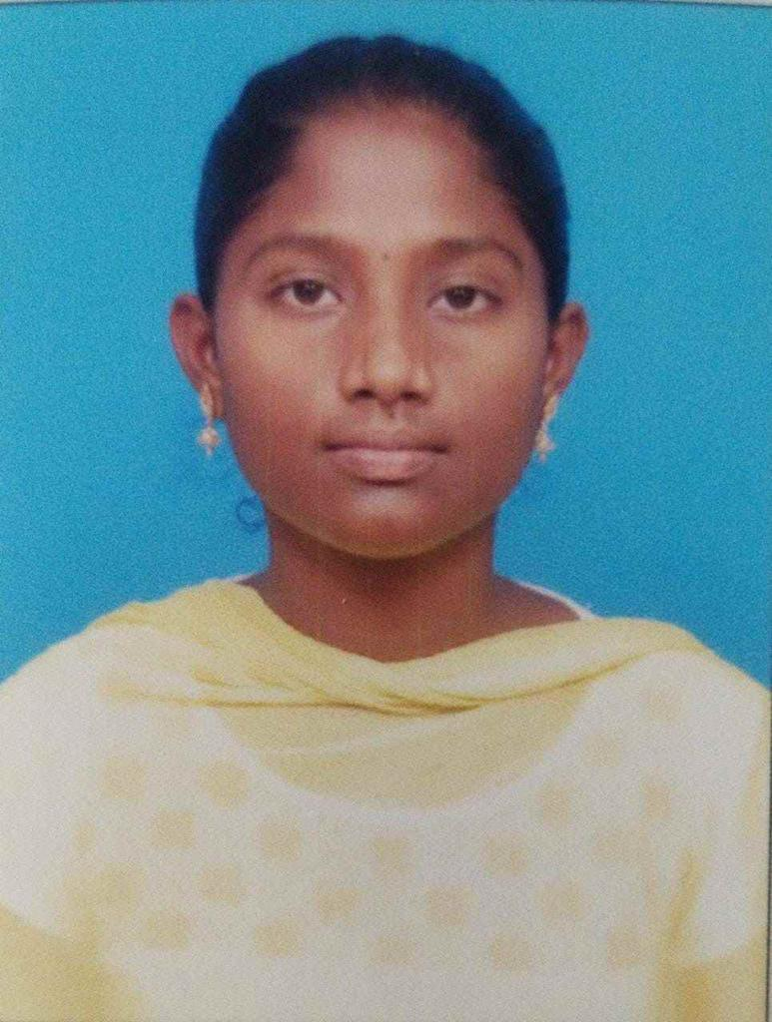 RESUME

NAME :MARIA FLORA JONES

ADDRESS : NO. 5,KASILLINGAM STREET, AYAPANNAGAR, AYAPAKKAM, CHENNAI-77

PHONE NO : 8220682663

MAIL ID : jj6329721@gmail.com

PERSONAL INFORMATION :

DATE OF BIRTH : 23.09.2005

GENDER : **FEMALE**

RELIGION : **CHRISTIAN**

FATHER’S NAME : **FRANCIS XAVIER. P**

MOTHER’S NAME : **JAMUNA THERESA. F**

MARTIAL STATUS : **UNMARRIED**

EDUCATIONAL BACK GROUND

COLLEGE / DEGREE : BHAKTAVATSALAM MEMORIAL COLLEGE FOR WOMEN-BSc.COMPUTER SCIENCE WITH DATA SCIENCE

CLASS OBTAINED : NIL

YEAR OF PASSING : 2026

SCHOOL :ST.JOSEPH’SMATRIC HIGHER SECONDARY SCHOOL, VILLUPURAM

STATE/CBSE : % OF MARKS / YEAR OF PASSING

STATE:89%/2023

PHOTO

TECHNICAL QUALIFICATION:

**PROFICIENT IN PYTHON, HTML,**

**COMPLETED COA(COMPUTER OFFICE AUTOMACHINE**

CERTIFICATE COURSE IF ANY:

**CERTIFIED IN OOPS IN PYTHON, GENERATIVE AI, DATA ENGINEERING AND BIG DATA.**

MY HOBBIES :

**READING BOOKS, DANCING**

GIVEN DETAILS ABOVE ARE TRUE TO MY KNOWLEDGE AND

BELIEF.

SIGNATURE